

**Arrange by :**

Hilman Maulana Anhar

M Dani Setiawan

M Naufal Azmi

**1SC8**

**Faculty :**

Mr. Muhammad Idham Khalif, S.Kom

**CCIT Fakultas Teknik-Universitas Indonesia**

**Kampus Baru UI Depok 16424**

**Project On**

HAD-Jek: Ojek Online

Developed by

Name : Hilman Maulana Anhar

M Dani Setiawan

M Naufal Azmi



**HAD-Jek: Ojek Online**

Batch Code: 1SC8

Start Date: October 27, 2018

End Date: October 31, 2018

Name of the Coordinator: Mr. Muhammad Idham Khalif, S.Kom

Names of Developer:

* Hilman Maulana Anhar
* M Dani Setiawan
* M Naufal Azmi

Date of Submission: October 31, 2018



**CERTIFICATE**

This is to certify that this report titled HAD-Jek: Ojek Online embodies the original work done by, Hilman Maulana Anhar, M Dani Setiawan, and M Naufal Azmi in partial fulfillment of their course requirement at NIIT.

Coordinator:

Mr. Muhammad Idham Khalif, S.Kom





**ACKNOWLEDGEMENT**

Authors would like to praise to Allah, Most Merciful bless and so authors can finish this Project 2 entitled **“HAD-Jek: Ojek Online”**. Author would like to thanks to Mr. Muhammad Idham Khalif, S.Kom as Lecturer who has given useful suggestion which are help author in writing this paper.

The writer realized that this paper far from perfection, then the writer will be very unfettered the chest and was encouraged, if colleagues and the guide's agreeing lecturer gave the suggestion & criticism for this paper perfection.



**SYSTEM ANALYSIS**

**System summary :** HAD-Jek: Ojek Online is online public transportation program, mainly helping people to go anywhere and send a package. HAD-Jek: Ojek Online is a one online public transportation provider. This program can provide many service, there are HAD-Ride, HAD-Car, and HAD-Send.

**System Processes :** HAD-Jek: Ojek Online is an online public transportation program.

**FLOWCHART**

**System process:** Index

This flowchart represents the main system process of HAD-Jek: Ojek Online

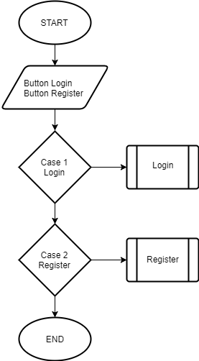

**FLOWCHART**

**System process:** Register

This flowchart represents the main system process of HAD-Jek: Ojek Online

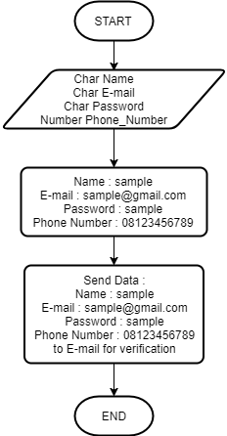

**FLOWCHART**

**System process:** Login

This flowchart represents the main system process of HAD-Jek: Ojek Online

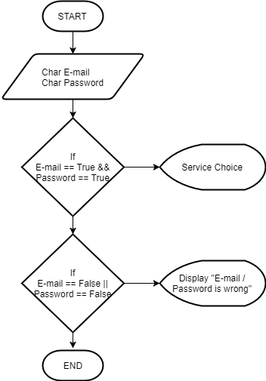

**FLOWCHART**

**System process:** Services Menu

This flowchart represents the main system process of HAD-Jek: Ojek Online

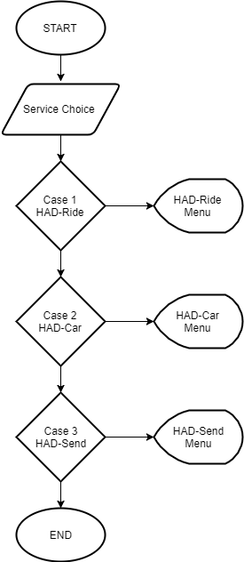

**FLOWCHART**

**System process:** HAD-Ride Service

This flowchart represents the main system process of HAD-Jek: Ojek Online

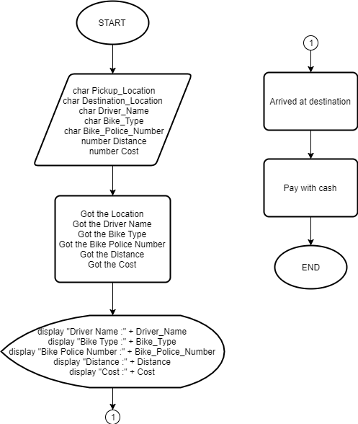

**FLOWCHART**

**System process:** HAD-Car Service

This flowchart represents the main system process of HAD-Jek: Ojek Online

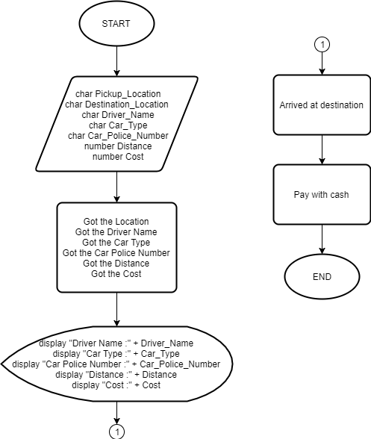

**FLOWCHART**

**System process:** HAD-Send Service

This flowchart represents the main system process of HAD-Jek: Ojek Online

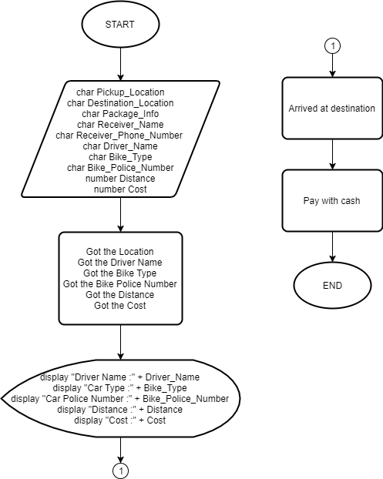

**Pseudocode**

**System Process**: Index

This pseudocode represents the main system process of HAD-Jek: Ojek Online

begin

button Login

button Register

case 1 : Login

begin

call login

break

end

case 2 : Register

begin

call Register

break

end

end

**Pseudocode**

**System Process**: Register

This pseudocode represents the main system process of HAD-Jek: Ojek Online

begin

Char Name

Char E-mail

Char Password

Number Phone_Number

display "Name :"

accept Name

display "E-mail :"

accept E-mail

display "Password :"

accept Password

display "Phone Number :"

Send Data :

Name, E-mail, Password, Phone_Number to email for vertification

end

**Pseudocode**

**System Process**: Login

This pseudocode represents the main system process of HAD-Jek: Ojek Online

begin

char E-mail

char password

display "Masukan E-mail"

accept E-mail

display "Masukan Password"

accept password

if email == true && password == true

begin

enter to service choice

end if

else email == false || password == false

begin

display "E-mail / password is wrong"

end if

end

**Pseudocode**

**System Process**: Services Menu

This pseudocode represents the main system process of HAD-Jek: Ojek Online

begin

button HAD-Ride

button HAD-Car

button HAD-Send

case 1 HAD-Ride

begin

display HAD-RIDE Menu

break

end

case 2 HAD-Car

begin

display HAD-Car Menu

break

end

case 3 HAD-Send

begin

display HAD-Send Menu

break

end

end

**Pseudocode**

begin

char Pickup_Location

char Destination_Location

char Driver_Name

char Bike_Type

char Bike_Police_Number

number Distance

number Cost

Process Got the Location , Got the Driver Name , Got the Bike Type , Got the Bike Police Number , Got the Distance , Got the Cost

display "Driver Name :" + Driver_Name

display "Bike Type :" + Bike_Type

display "Bike Police Number :" + Bike_Police_Number

display "Distance :" + number Distance

display "Cost :" + number Cost

end

**System Process**: HAD-Ride Service

This pseudocode represents the main system process of HAD-Jek: Ojek Online

**Pseudocode**

begin

char Pickup_Location

char Destination_Location

char Driver_Name

char Car_Type

char Car_Police_Number

number Distance

number Cost

Process Got the Location , Got the Driver Name , Got the Car Type , Got the Car Police Number , Got the Distance , Got the Cost

display "Driver Name :" + Driver_Name

display "Car Type :" + Car_Type

display "Car Police Number :" + Car_Police_Number

display "Distance :" + number Distance

display "Cost :" + number Cost

end

**System Process**: HAD-Car Service

This pseudocode represents the main system process of HAD-Jek: Ojek Online

**Pseudocode**

begin

char Pickup_Location

char Destination_Location

char Package_Info

char Receiver_Name

char Driver_Name

char Bike_Type

char Bike_Police_Number

number Distance

number Cost

Process Got the Location , Got the Driver Name , Got the Bike Type , Got the Bike Police Number , Got the Distance , Got the Cost

display "Driver Name :" + Driver_Name

display "Car Type :" + Car_Type

display "Car Police Number :" + Car_Police_Number

display "Distance :" + number Distance

display "Cost :" + number Cost

end

**System Process**: HAD-Send Service

This pseudocode represents the main system process of HAD-Jek: Ojek Online

**Dry Run Table**

**System Process**: Main System

This dry run table tests the main program of HAD-Jek: Ojek Online

